

Continuning

Education

Program

Center for Computing and Information Technology

**ISAS ( Information Search and Analysis Skill)**

**“Oculus Rift as Virtual Reality Revolution”**

Name :

♦ Anindya Putri Erniandara

♦ Melinda N.P.D

♦ Muhammad Hudya Ramadhana

Class : 1SC2 (PNJ)

**Preface**

First, let us give praise to Allah S.W.T who give guidance to us untill we can complete our ISAS entitled "Oculus Rift as Reailty Virtual Revolution".  
As we write this article, we get a lot of support from various parties. Among others are :

1. Our parents, who always help in the form of spirit and material.
2. Dr. Aries Subiantoro, .M.Sc as director of CCIT Faculty of Engineering, University of Indonesia.
3. M. Octaviano S.St as our teachers who have provided guidance and support and referrals to us so that we can finish ISAS.
4. our friends who always give the information that they know, exchange ideas and give encouragement to us in writing this article.

We know that the results of our article is far from perfect and there are still many shortcomings, we hope readers will give comments and suggestions in building this article in order to become better. We hope this article can be useful for those who read or hear, especially for CCIT students of the Faculty of Engineering UI.

Our ISAS titled “Oculus Rift as Virtual Reality Revolution” is an tool to display virtual images from glasses. Many vendor try to develop their own tool which similiar to Oculus Rift. We hope Oculus Rift can give many advantages for all human needs in technology. Also we hope the ISAS will be benefir for the reader and influential for IT developments.

Depok, 3 September 2015

Author

I

**TABLE OF CONTENTS**

PREFACE**I**

TABLE OF CONTENTSII

TABLE OF FIGUREIII

**CHAPTER I : INTRODUCTION**

I.1 Background1

I.2 Writing Objective1

I.3 Problem Domain2

I.4 Writing Methodology2

I.5 Writing Framework2

**CHAPTER II : BASIC THEORY**

II.I Definition of Oculus Rift4

II.2 History of Oculus Rift4

II.3 The Components of Oculus Rift4

II.4 Version of Oculus Rift6

**CHAPTER III : PROBLEM ANALYSIS**

III.1 Usefulness of Oculus Rift in the real world9

III.2 Impact of Oculus Rift 12

**CHAPTER IV : CONCLUSION AND SUGGESTION**

IV.1 Conclusion13

IV.2 Suggestion14

**BIBLIOGRAPHY** 14

II

**TABLE OF FIGURES**

Figure 2.1 Components of Oculus Rift4

Figure 2.2 Oculus Rift HD Prototype 6

Figure 2.3 Oculus Rift Developer Kit 7

Figure 2.4 Oculus Rift Developer Kit 27

Figure 2.5 Oculus Rift Crystal Cove Prototype 8

Figure 2.6 Oculus Rift Consumer Version 8

Figure 3.1 Dining Room in Virtual Reality 9

Figure 3.2 3D Car Model 9

Figure 3.3 Pokemon Game on Oculus Rift 10

Figure 3.4 Medical Education Game on Oculus Rift 10

Figure 3.5 U.S Soldier trying parachute training using Oculus Rift 11

Figure 3.6 The Swedish Virtual Reality Museum on Oculus Rift 11

III

**CHAPTER 1**

**INTRODUCTION**

**I.1 Background**

Background of Oculus Rift arise from the desire of mankind who wants to create a virtual world technology that can be used for a variety of advantages. The beginning of making this technology is based on the simulation technology that makes human beings as if plunging into the actual incident. This technology was created by Palmer Luckey to handle difficult things and limited by natural resources, funds, equipments and humans in order to be resolved and can alleviate operational costs in all aspects related to technology.

At this modern era, so many human needs in the world of technology. This can be seen in terms of limited resources which make human being difficult to be handled. In this Oculus Rift technology, all made virtually without the need for extensive space in the real world. Oculus Rift makes human work easier.

Virtual reality technology is also beginning to look inside the Japanese cartoon "Sword Art Online". Where a helmet users can enter a big virtual world and can interact with his virtual body. Eventually the humans trying to create a virtual reality tool that can interact with other tools that are integrated with the virtual reality tools. The tool is called the Oculus Rift, a pair of glasses that can realize a virtual world that is seen as the real world.

Oculus Rift virtual reality comes as a bridge between the virtual world and the real world. Currently the tool similar to the oculus rift has developed in several countries with their own style. Project Morpheus is example made by Sony that can be used to play games. However the reality, virtual reality is not only used for gaming. But can be used for military, medical, and flight simulator. Oculus Rift very assists human life in this modern technological era at section of time, cost, location and finances that make this technology continues to be developed and received support from various parties. Oculus Rift is believed to help the human work easier and better than ever.

**1.2 Writing Objective**

The purpose of this ISAS are :

● to understand the development of Oculus Rift.

● to understand utility of Oculus Rift in various field.

● to knowing impact of Oculus Rift

1

**1.3 Problem Domain**

In accordance with the title of ISAS "Oculus Rift as Virtual Reality Revolution". We will discuss:

♦ How the Oculus Rift useful in our lives.

♦ Knowing the component on Oculus Rift.

♦ Knowing the impact of Oculus Rift technology.

**1.4 Methodology Writing**

The method used is the method of browsing from internet and read someone review article.

**1.5 Writing Framework**

The paper was written by systematic as follows :

**CHAPTER I : INTRODUCTION**

**1.1 Background**

Discusses the history of Oculus Rift, Human needs in technology and the reason why Oculus Rift Created.

**1.2 Writing Objective**

The purpose of this article is to understand the development of virtual reality with tool called Oculus Rift .

**1.3 Problem Domain**

Mention several points about the limitations of the problem to be discuss.

**1.4 Methodology Writing**

Our team use the method of browsing and observing.

2

**1.5 Writing Framework**

Describe the entire of ISAS

**Chapter II Basic of Theory**

Tell the definition about Oculus Rift,History about Oculus Rift,the use of Oculus Rift, and the components inside Oculus Rift.

**Chapter III Problem Analysis**

Analyzing and solve the problem that contained in problem domain.

**Chapter IV Conclusion and Suggestion**

Conclude and suggest related to ISAS.

3

**CHAPTER II**

**BASIC OF THEORY**

**II.1 Definition of Oculus Rift**

Oculus Rift is a technology that allow users to interact with real objects being simulated using a computer. Actually, Virtual memory is the environment / objects that exist only in the imagination that is capable of generating three-dimensional atmosphere that makes the user as if physically involved.

Oculus Rift connect between real life and virtual world. With this tool people can interact in virtual world. This technology bring many advantages for our life, any problem which need a big funds or wide place will be handled with this technology. This technology is able to make people who play in the virtual world to believe that they are in the real world.

Example: flight simulation.

Pilots can use a virtual reality system to perform flight simulation before the actual flight.

**II.2 History of Oculus Rift**

Oculus rift created by Palmer Luckey. Beginning of making the oculus is only intended to gamers.when initial appearance, he gets donation from Backer (donors) who are mostly maniac game and indeed Oculus Rift is intended only to play game. Then the main vision is "one step to get into the game real world" since the user will feel really be in the game world.

On 25 March 2014 Oculus VR bought by Facebook for US $ 2 billion. $ 400 million in cash, the rest in shares form. People worry if Facebook buy Oculus VR, the development will be not for game again. But Mark Zuckeberg said that Oculus VR will be helped by Facebook Company at software section only, not at hardware section. Zuckeberg thinks this tool will be a strong candidates as social platform and communication at the future.

**III.3 Components of Oculus Rift**

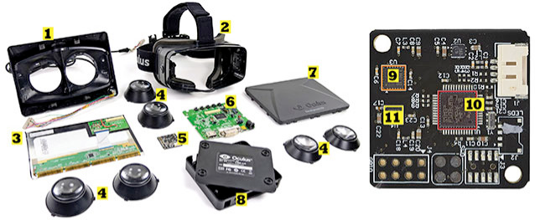

Figure 2.1 Components of Oculus Rift

(REF: <http://eandt.theiet.org>)

4

There are 11 part inside Oculus Rift :

1. **Lens mounting**

The usefulness of this lens as a convex lens placed.

1. **Headset**

This part is body of lens mounting placed. When you use Oculus Rift, you also look inside this part like using glasses.

1. **LCD Board**

This part functions is to displaying an image,text and menus on Oculus Rift.

1. **Lenses (multiple options)**

This part function is to displaying an image through a lens. When small image viewed without the oculus rift, will be big when you use Oculus Rift. This is the effect of a convex lens which used as a lens.

1. **Adjacent Reality Tracker Board**

This part function is to regulate the movement of the sensor head. In this part there Gyro / accelerometer InvenSense, Microcontroller STMicroelectronics and Magnetometer.

1. **Control Box Board**

This part function is controlling the choice which we choose and confirmation to the system when we choose a choice.

1. **Lens mounting cover**

This part is a cover of the lens and headset. This cover protects the components inside from the front, in this part there is also LCD Board which display an image.

1. **Control Box Container**

This part also serves as a lens cover, protects the control board that serves as a control in the oculus rift.

1. **Gyro sensor / Accelerometer Invense**

Accelerometer Invense sensor is required to change the display orientation from vertical to horizontal or vice versa. While the gyro sensor is a sensor for measuring or maintaining orientation, with the provision of angular momentum principle.

5

1. **Microcontroller ST Microelectronics**

Microcontroller is a functional system on a chip. It contains a processor core, memory (a small amount of RAM, program memory, or both), and input and output equipment.

1. **Magnetometer**

This part serves as a button to choose a choice. When you look at the choice and press this button, your choice will be displayed.

**II.4 Version of Oculus Rift**

There are 6 version of Oculus Rift :

1. **Oculus Rift HD Prototype**

This is the first generation of Oculus Rift. This stuff is not for sell but for Development of Oculus Rift. This is a start of Oculus Rift to evolve.

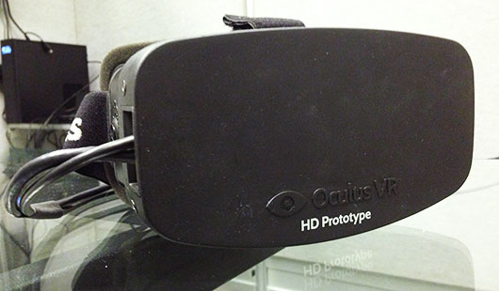

Figure 2.2 Oculus Rift HD Protoype

(REF: [www.oculus.com](http://www.oculus.com))

1. **Oculus Rift Developer Kit**

This is the development of Oculus Rift from HD Prototype. The design was very simple but the performance is better than HD prototype. But when this item on sale, game developers side give a feedback about many bugs when this item used.

6

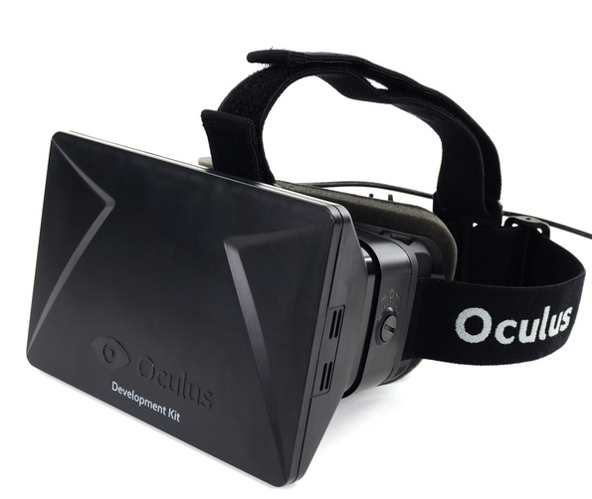

Figure 2.3 Oculus Rift Developer Kit 2

(REF: [www.display-central.com](http://www.display-central.com))

1. **Oculus Rift Developer Kit 2**

This is development of the first Developer Kit. There are many improvements in this version. an example is the increase in visual section which more stable and many bugs resolved.

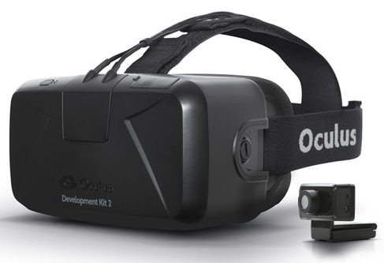

Figure 2.4 Oculus Rift Developer Kit 2

(REF: www1.oculus.com)

7

1. **Oculus Rift Crystal Cove Prototype**

Crystal Cove Prototype is not much different from the Developer Kit 2, but the more comfortable than Developer Kit 2 version. This version improve at comfort side because this version is a final version improvement to be published for all gamer.

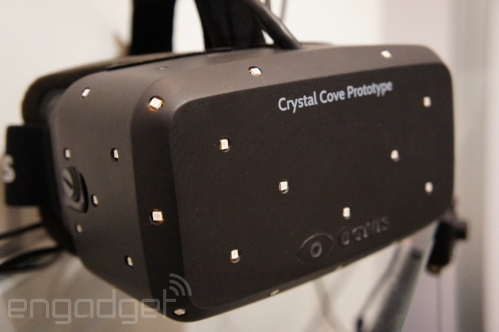

Figure 2.5 Oculsu Rift Crystal Cove Prototype

(REF: [www.engadget.com](http://www.engadget.com))

1. **Oculus Rift Consumer Version**

Oculus Rift Consumer Version is a product which sold for gamers and game developers. In this version, all bugs in previous versions have been fixed and the visual has been increased to make gamers more comfortable. Elegant design in this version also makes many people want to have it.

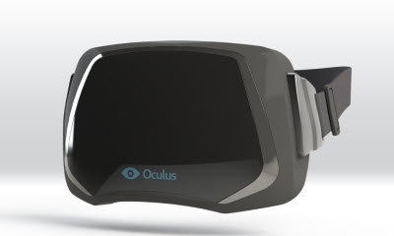

Figure 2.6 Oculus Rift Consumer Version

(REF: <http://venturebeat.com/>)

8

**CHAPTER III**

**PROBLEM ANALYSIS**

**III.1 Usefulness of Oculus Rift in the real world**

There are many usefulness of Oculus Rift, this tool help human to make works more easy.

Here the example of Usefulness :

1. Architecture Engineering

With Oculus Rift, Architecture can create a building or interor design with the real technology that make the Architecture feel the real room / real building.

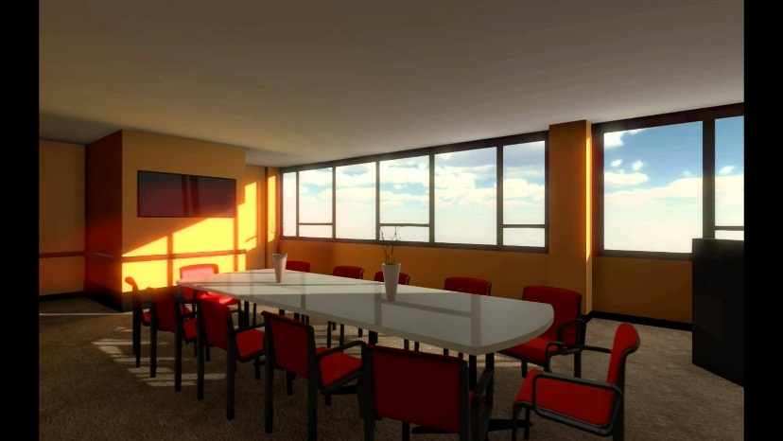

Figure 3.1 Dining Room in Virtual Reality

(REF: <http://youtube.com>)

1. **Business**

With Oculus Rift, a business man shouldn’t need bring their car to the mall or any exhibition place again. They just need bring oculus rift and can show their product in Virtual Reality technology. So the buyer will know any information of the product.

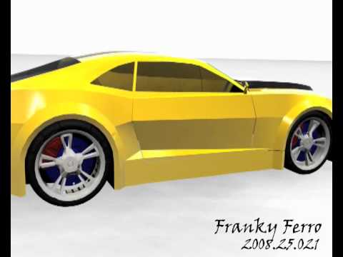

Figure 3.2 3D Car Model

(REF: <http://youtube.com> )

(REF: <http://youtube.com>)

9

1. **Entertainment**

With Oculus Rift, you can play games that bring you the real sensation like in the real world.

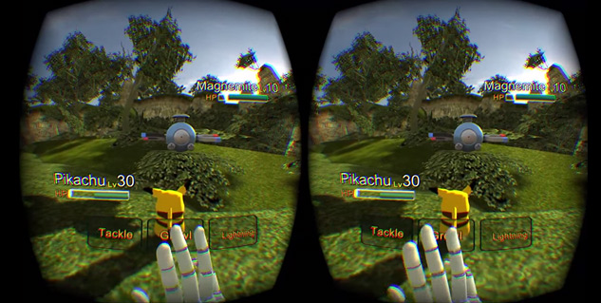

Figure 3.3 Pokemon Game on Oculus Rift

(REF: <http://megames.com>)

1. **Medical & Education**

With Oculus Rift, any College Student who take faculty of medical will be easy to create or learn body’s anatomy which can rotate anywhere. Student also can see the earth from the sky, create structure of molecule, and study about the planet solar system.

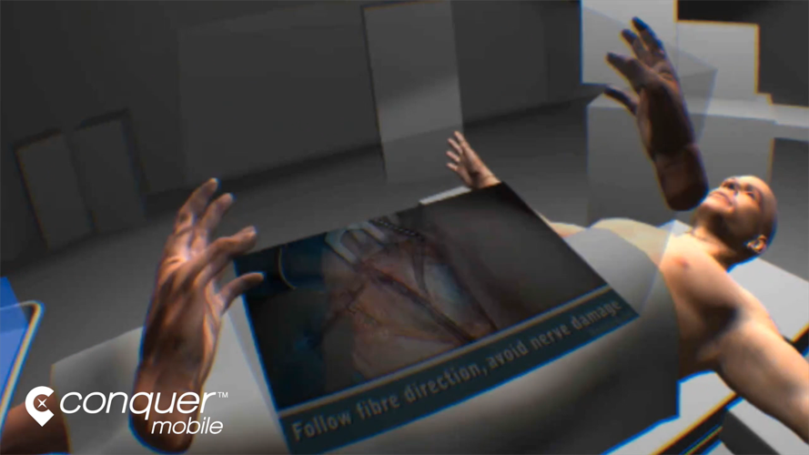

Figure 3.4 Medical Education Game on Oculus Rift

(REF: [http: //conquermobile.com](http://conquermobile.com))

10

1. **Military**

Now Oculus Rift is used by Military to free fall parachute training,laying areas of military operations, which will be used to put the troops, or even used as a guide for smart missile (missile).

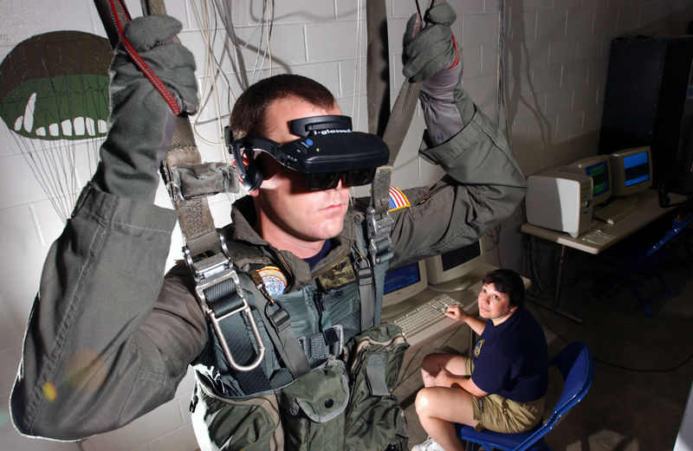

Figure 3.5 U.S Soldier trying parachute training using Oculus Rift

(REF: [www.cs.unc.edu](http://www.cs.unc.edu))

1. **Art & History**

Oculus Rift can show the visual of museum which have any historical item. Oculus Rift also can show all the past history of the building which could be engineered in 3D. This is good for our children in the future.

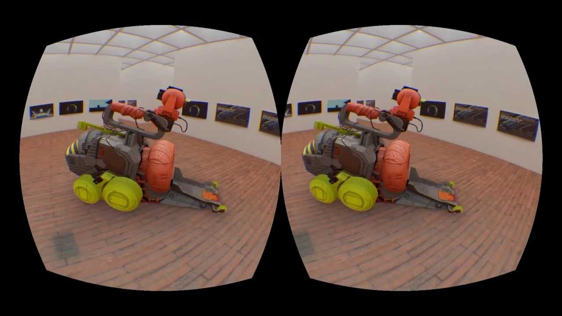

Figure 3.6 The Swedish Virtual Reality Museum on Oculus Rift

(REF: [http://](http://itunes.apple.com)youtube.com)

11

**III.2 Impact of Oculus Rift**

Besides advantages of Oculus Rift, there must be disadvantages that will be obtained when use Oculus Rift.

1. **Health**

This technology will be affect our health. If we play game too long, our eyes will be tired and our eyes will be nearsighted. And your hearing will be damaged due to the effects of the use of a headset that too often. The use of a headset that is too often also will cause a lot of bacteria in our ears. And your body will be weary because the activity is too monotonous.

1. **Labor**

Before this technology founded, if we want to see a historical objects, pictures or other heritage we should go to the museum. Imagine if people doesn’t want to go to museum and prefer to buy and use Oculus Rift. People who work on the museum will be stopped because the museum company didn’t have any income.

1. **Addicted**

Playing a game is like smoking. If we can’t control ourselves, we will be addict to playing a game. This is horrible for us, if our child playing game with Oculus Rift and they be addict. If they smart, they won’t affect their score at school. But how about if they lazy? It will affect their score at school. So, Parents must control their children when playing a game which use Oculus Rift.

12

**CHAPTER IV**

**CONCLUSION AND SUGGESTUION**

**IV.1 Conclusion**

* Oculus Rift is a technology that allow users to interact with real objects being simulated using a computer. Actually, virtual memory is the environment / objects that exist only in the imagination that is capable of generating three-dimensional atmosphere that makes the user as if physically involved.

Example : Flight Simulation

* Oculus rift created by Palmer Luckey. Beginning of making the oculus is only intended to gamers. When initial appearance, he gets donation from Backers (donors) who are mostly maniac game and indeed Oculus Rift is intended only to play game. Then the main vision is "one step to get into the game real world" since the user will feel really be in the game world.
* There are 11 part inside Oculus Rift :

1. Lens Mounting
2. Headset
3. LCD Board
4. Lens (multiple options)
5. Adjacent Reality Tracker Board
6. Control Box Board
7. Lens Mounting Cover
8. Control Box Container
9. Gyro sensor / Accelerometer Invense
10. Microcontroller ST Microelectronics
11. Magnetometer

* Version of Oculus Rift :

1. Oculus Rift HD Prototype
2. Oculus Rift Developer Kit
3. Oculus Rift Developer Kit 2
4. Oculus Rift Crystal Cove Prototype
5. Oculus Rift Consumer Version

* Usefulness of Oculus Rift in the real world :

1. Usefulness of Oculus Rift in the real world
2. Business
3. Entertainment
4. Medical & Education
5. Military
6. Art & History

13

* Impact of Oculus Rift

1. Health
2. Labor
3. Addicted

**IV.2 Suggestion**

1. The Oculus Rift must be developed to be used by mankind in various fields
2. Oculus Rift should be made comfortable so the users will be more comfortable to use it.
3. The cost of the production and sale of equipment Oculus Rift shall be made low so that all mankind can feel the virtual reality
4. Parents must supervise their children in using oculus rift in order to avoid unwanted things
5. All aspects due to the Oculus Rift must be minimized in order to avoid unemployment.
6. Oculus Rift should be best possible in various fields.

**BIBLOGRAPHY**

1. <http://belajarberbagi20.blogspot.com/2015/05/oculus-rift.html> accessible through Firefox on [ 30/08/2015 ]
2. <http://danandio.blogspot.com/2015/01/oculus-rift-rift-adalah-peranti-layar.html> accessible through Firefox on [ 30/08/2015 ]
3. <http://oculusvr.com> accessible through Firefox on [ 30/08/2015 ]
4. <http://dito.blog.uns.ac.id/2014/09/15/berbagai-sensor-yang-dibenamkan-pada-perangkat-android/> accessible through Firefox on [ 31/08/2015 ]
5. <http://duniainternet.net/apple-gunakan-2-sensor-supaya-hemat-baterai.html> accessible through Firefox on [ 31/08/2015 ]
6. <http://eandt.theiet.org/magazine/2013/05/teardown-oculus-rift-3d.cfm> accessible through Firefox on [ 31/08/2015 ]
7. <http://metro.co.uk/2015/06/11/oculus-rift-works-with-xbox-one-oculus-touch-controller-revealed-5241734/> accessible through Firefox on [ 31/08/2015 ]
8. <http://popsci.com/oculus-rift-how-it-works> accessible through Firefox on [ 31/08/2015 ]
9. <http://www.amazon.com/Oculus-Rift-Developers-Kit-Dk2/dp/B00F5CWD0I> accessible through Firefox on [ 31/08/2015 ]

14